

Appointment

**Curriculum Leader for PE**

Salary Scale: MPS/UPS plus TLR 2b

Required: September 2025

**ADVERT**

We are looking to appoint a new Curriculum Leader for PE. This post could be full time or 0.8 part time. It is a fantastic opportunity for those seeking career progression to their first position of subject leadership or a move from an existing position of leadership. The post involves leading and managing a passionate and dedicated PE department, whose extra-curricular programme is exceptional. The department benefits from specialist staff who and excellent sports’ facilities.

The successful candidate will have a clear vision for the subject and be able to build upon current successes to lead the department into a new phase of development. They will therefore be a passionate, student-centred, reflective and creative professional with excellent inter-personal skills. They will have a deep understanding of teaching, learning and assessment, with particular expertise in planning and implementing an exciting curriculum. In all they do, they will be a team player and draw colleagues together to work together.

Wyvern College is a popular and happy school, where staff and students feel valued and appreciated. Students are polite, hard-working and well behaved. They are keen to learn and they achieve well above national expectations. Staff morale is high; turnover is low and there is a strong sense of team work and community. Staff are proud of their college and genuinely excited about the next stage of its development. Leaders and Governors are held in high esteem. We have on-site nursery and gym facilities with staff discounts. People rarely leave Wyvern and those who do, often return!

Wyvern is a 11-16 mixed comprehensive school, serving the communities of Fair Oak, Horton Heath, Bishopstoke, Durley and Upham and the surrounding area. Increasingly, families from outside the catchment area are seeking Wyvern places for their children. Consequently, it is oversubscribed.

Closing date for applications: Monday 24th February 2025.



**Letter from the Head teacher**

Dear Prospective Applicant,

Thank you for your interest in applying for the position of Curriculum leader for PE at Wyvern College. This is an exciting time to be joining Wyvern. We have recently had an Ofsted inspection (December 2023). The school was judged to be a strongly “Good” school. The report validated our own assessment of the college – there were no surprises! It described Wyvern well:

“*Wyvern College is inclusive with a strong community feel. Pupils respect diversity and feel confident to be different. Relationships are very positive. As one parent said, ‘My daughter has flourished due to the positive role models and encouraging culture at this school.’ Pupils feel safe and enjoy attending. The school’s values of ‘think, grow, care’ underpin all aspects of school life. There are high expectations for what all pupils can achieve. The school strives to provide the same high-quality education to all pupils, regardless of their starting points or the challenges they face. Pupils consequently achieve well*.”

The class or 2024 attained some of the best grades the college has had and attainment at the 9-7, 9-6, 9-5 and 9-4 thresholds actually increased from 2023 amidst the back drop of declining attainment nationally. Strong exam results are crucial for setting students up for high quality careers which give their lives meaning, purpose and fulfilment, but I want them to have fun and enjoy their school days too, and to live lives enriched by the arts, sport, charity, community and a deep sense of public service. A Wyvern education is not, then, just about great exam results but is defined by our vision of Think, Grow, Care:

**Think deeply**, read widely, discuss openly and listen intently. Study with PRIDe, forever Prepared, Respectful, Involved and Dedicated.

**Grow personally**, in confidence, wellbeing and individuality. Expand your interests and friendships. Develop a conscience and the moral courage to act on it.  Embrace personal challenges.

**Care passionately** about people and causes. Appreciate the help of others; help them through service, teamwork, kindness and leadership. Make this world a better place as an informed and influential citizen, respecting British and universal values.

The college is characterised by high quality relationships between staff and students. Students are polite, friendly and well behaved; they are loyal to their college and enjoy warm, mutually respectful relationships with staff. Teachers can get on and teach the lessons they want and students can learn without disruption.

A high level of trust exists between the leadership group and staff – this is something I am very proud of. The Ofsted inspector said, “School leaders have a strong sense of moral purpose. Staff are proud to work at the school. They believe that leaders consider their well-being and workload. Teaching and support staff, including those in the early stages of their careers, feel supported and valued as they develop their expertise in helping pupils to learn and achieve”. At Wyvern leadership is about service not being served. Our job as leaders is to make sure that those working in the front line with students – our staff – have everything they need to do the best job they can and that includes us being there on the front line with them too. The successful candidate will need to personify this ethos of service to colleagues.

Above all else, Wyvern is a happy school and the successful candidate will be someone who will positively affect the ethos of the college through their actions and words.

We are guided by the principles of Tough Care and the successful applicant will be committed to these: the idea that if we want the very best for our students we have to demand the very from them: the best attendance, the best behaviour the best work and the best attitude. We cannot think very highly of our students if we do not challenge poor effort, behaviour, attendance and work. It is because we do care that we sometimes have to say to students “that is not good enough.” By challenging them in this way, we know they will have choices and chances in their lives that they wouldn’t have if we just let students set their own standards.

I hope this brochure provides you with the information you need to decide whether this is the right role and the right school for you. Please do get in touch with me if you would like to ask any questions or discuss any aspects of the job or college: [b.rule@wyvern.hants.sch.uk](mailto:b.rule@wyvern.hants.sch.uk) .

With best wishes,

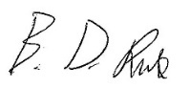

Ben Rule

Head teacher



**Key Information: The College**

**College Context**

* With 1351 students on roll, Wyvern College is bigger than the average secondary school with a PAN of 270 for each year group. There is a trend of increased admission applications to the college: in 2018-19, student numbers were well below the PAN for years 9-11. The college is now full and oversubscribed in every year. There has been a concurrent increase in the proportion of students coming to Wyvern as their first-choice school. These trends reflect the local community’s increased confidence in the college.
* Wyvern is an academy converter, mixed comprehensive school. The proportion of disadvantaged students is 19% which is well below the national average. Overall, 10% of students have low prior attainment, 40% middle and 47% high.
* Most students are white British: the proportion of students who speak English as an additional language is low at 6%
* The proportion of students receiving help for SEN is 19%; 58 students have an EHCP; 202 other students are on the SEND register.
* The college makes occasional use of alternative provision: 21 students are currently in some form alternative provision due to their SEND needs or emotional needs.

**Summary of the College’s Strengths**

* The college is known and respected for its holistic education, with a strong emphasis on character education, personal development and social responsibility.
* The range and number of extra-curricular activities is exceptional.
* Student numbers are rising and the college is now oversubscribed, reflecting the high regard it is held in by the local community.
* Students throughout the college attain higher grades than local, regional and national averages.
* Outcomes in the Ebacc subjects of Maths, Science, MFL and Humanities are especially strong, with attainment and progress rates significantly above the county and national averages.
* Results in PE GCSE have improved significantly, with attainment and progress rising significantly in the last two years.
* The gender gap between boys and girls has reduced significantly from being much greater than the national gap to much lower.
* Attainment and progress scores for disadvantaged students, SEND students and low attaining students are especially strong, reflecting the inclusive nature of the college.
* A culture of high expectations and academic standards exist: high attainers on entry make good progress overall and across the range of subjects.
* Behaviour has improved significantly, as expectations rise each year, the vast majority of students’ behaviour improves each year. The college is always keen to improve behaviour further and continues to look as all ways in which this can be achieved.
* Relationships between staff and students are positive and make a strong contribution to good behaviour. The vast majority demonstrate positive attitudes to learning, every lesson, every day. The ratio of positive achievement points to negative behaviour points if 18:1
* Parents and students recognise that pastoral care is a real strength of the college.
* There is a very wide range of subjects for students to study at KS4.
* Staff morale is high and staff are proud to work at Wyvern.
* Governors (Trustees) are dedicated and involved; they provide strong strategic leadership and support for staff.

**Tough Care**

We are guided by the principles of Tough Care: the idea that if we want the very best for our students we have to demand the very from them: the best attendance, the best behaviour the best work and the best attitude. We cannot think very highly of our students if we do not challenge poor effort, behaviour, attendance and work. It is because we do care that we sometimes have to say to students “that is not good enough.” By challenging them in this way, we know they will have choices and chances in their lives that they wouldn’t have if we just let students set their own standards.

Tough care is about having high expectations and holding students accountable to these. We have one, common set of behavioural expectations for all classrooms which ensures consistency in approach and means that no teacher can be accused of picking on students who they do need to reprimand.

Tough care means both supporting students to meet our standards and also following up when they don’t.

Students who routinely do not meet our expectations, despite our considerable support, are moved on to alternative provision and we do this as early as possible, usually in years 7 and 8 to ensure that they can get the more specialist support they need to become engaged in learning from a different model than the one mainstream schools can provide.



**Key Information: The PE Department**

The PE department benefits from a wide range of facilities: a large departmental office; a gym; a sports’ hall; a dance studio; a fitness studio with weights and cardiovascular machines; a full size all-weather pitch (3 years old); fields, pitches, courts and an athletics track.

The PE team comprises of 7 teachers: they are highly collaborative and work well together to implement the PE curriculum and the extra-curricular programme. They have successfully run PE GCSE for many years and have recently introduced Sports Studies OCR, with the first cohort currently in year 11.

The college timetable operates a two-week cycle of 50 one-hour lessons. For years 7-11, students have 2 hours of PE per fortnight at Key Stage Three (years 7-8) and one hour per fortnight at KS4 (years 9-11). A large proportion of students opt in year 8 to do a sport related course as an option. Students have an additional 5 hours per fortnight in each of years 9, 10 and 11 to complete these courses. This generous allocation of time means that there is scope to teach courses in detail and to broaden and enrich students’ learning beyond exam specifications.

The PE Department runs a wide ranging extra-curricular programme across a wide range of activities and successfully compete in many district and county events. In addition, they run a number of internal House Sporting Competitions with strong participation. The college has a business arm called Community Enterprise which oversees facilities hire and runs an extensive programme of classes, lettings and courses which members of the local community use.

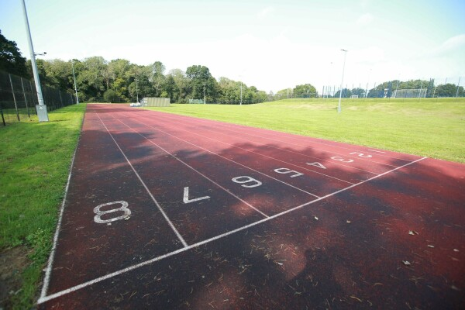

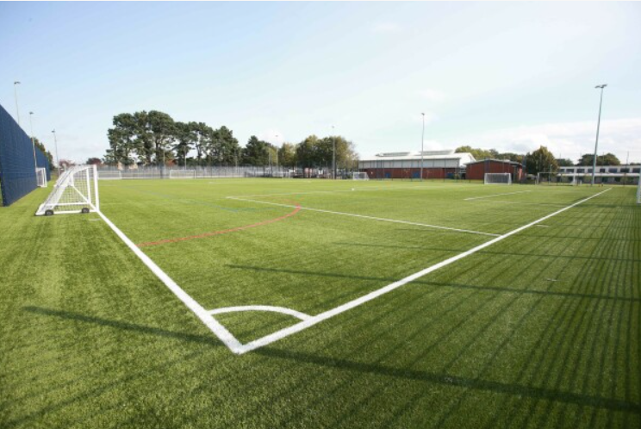

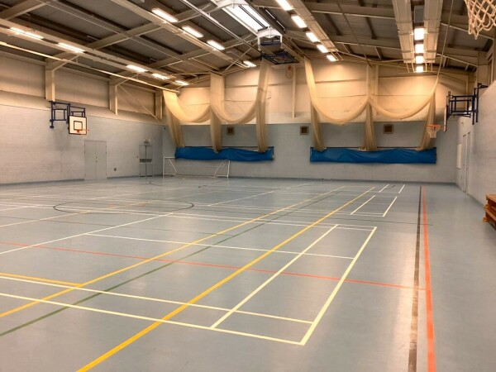

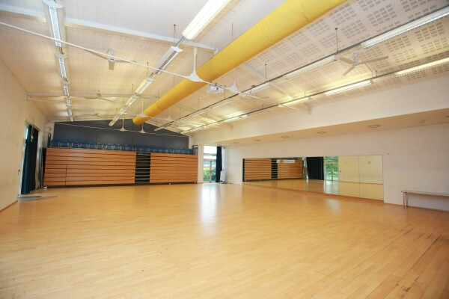

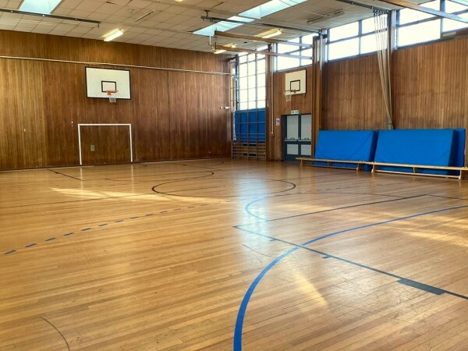

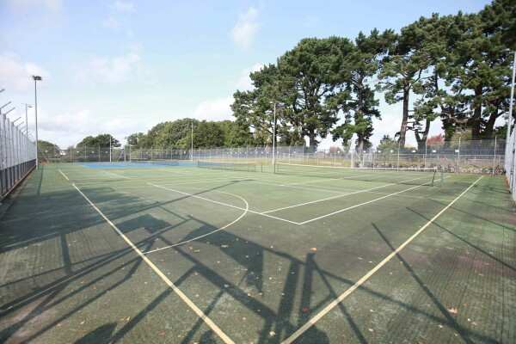

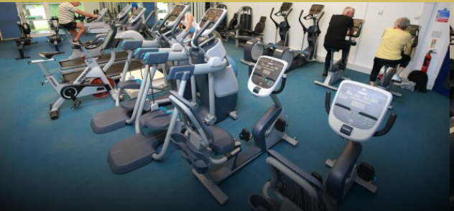



**Key Information: Job Description**

|  |  |
| --- | --- |
| **Job Description – Curriculum Leader PE** | |
| **Reporting to:** | The SLT Line Manager – Senior deputy Head teacher |
| **Responsible for:** | * Leadership and management of the PE department, including staff wellbeing. * Implementation of the PE curriculum in line with the college Curriculum Statement. * Achievement of consistently strong teaching, learning and assessment in PE. * Achievement of strong student progress and attainment in PE. |
| **Working time:** | Full time or 0.8 part time |
| **Salary/grade:** | TLR 2b |
| **Main responsibilities:** | **Leadership and Management**   * Create and communicate a vision for PE education that inspires both staff and students * Participate in the staff recruitment process for vacancies in PE. * Manage the department budget to ensure value for money and implementation of the ambitions set out in the college Curriculum Intent statement. * Maintain regular and effective communication with staff, parents and students. * Create an environment where staff wellbeing is protected and morale is kept high. * Implement college-wide policies in PE: curriculum, assessment, teaching & learning, behaviour, exams. * Plan the use of department meeting time to advance identified improvement priorities. * Work with the SLT line manager in designated meeting time to produce an up to date Subject Improvement Record to serve as an ongoing self-evaluation and department improvement document.   **Curriculum Intent and Implementation**   * Maintain the department’s Quality of Education statement, setting out: the department’s vision for education, the curriculum end points for KS3 and KS4, and ensuring that the design of the Art curriculum and its assessment conform to the college principles for effective design (specified below). * Work with departmental colleagues to ensure there is an inclusive programme of extra-curricular activities. * Exemplify effective teaching and curriculum implementation in your own classroom.   **Securing high consistently high standards**   * Analyse progress data and act accordingly to refine learning plans in order to close any gaps and address misconceptions. * Participate with the Senior Deputy Head teacher in Progress Meetings and Exam Review Meetings. * Implement a QA/monitoring schedule. * Monitor the progress of students and sub-groups of students with staff and plan appropriate support / interventions to remedy slow progress. * Ensure that standardisation and moderation of student work takes place in department time to ensure that accurate assessment data is generated consistently across the department. |
| **Meetings** | * Attendance at Curriculum Leaders’ Meetings |



**Key Information: Person Specification**

|  |  |  |
| --- | --- | --- |
| CATEGORY | ESSENTIAL | DESIRABLE |
| **Qualifications and training** | * Degree * Qualified Teacher Status. * Evidence of a commitment to own professional development. | * Further professional qualifications. |
| **Experience** | * An experienced teacher with a track record of excellent outcomes. * An experienced leader of team player who can demonstrate how their work has led to excellent student outcomes beyond their own classroom. | * Experience of providing support and guidance to others. |
| **Skills, knowledge and abilities** | * Excellent understanding of the components which comprise outstanding teaching, learning, curriculum and assessment. * A sound understanding of the latest developments in education. * Use of assessment information to improve practice and raise standards. * Evidence of ability to lead and manage change effectively. | * Delivery of CPD. |
| **Personal qualities** | * Able to take a whole-college perspective on issues and problems. * Motivated to make a difference to the quality of education students receive. Fully committed to the principles of Tough Care, including PRIDe. * Discrete and professional in approach; trustworthy with sensitive and confidential information. * Emotionally and socially intelligent: can read people and situations well, responding accordingly in appropriate ways. * Generates a positive ethos and working environment around them through their words and actions to others. * Able to think both strategically and operationally: articulating what needs to change, the reasons why and the best way how. |  |
| **Wyvern Leaders’ Code of Conduct** | | |
| **The frontline comes first.**We serve staff, ensuring they have everything they need in their classrooms and offices to do the very best they can. Our job as leaders is to make the frontline jobs as easy and impactful as possible and to prioritise staff wellbeing. Supporting the frontline involves being a visible, proactive presence in and around the department.  **Creative tension**: we welcome respectful disagreement with each other, knowing that it will lead to decisions that have been stress tested. We need to have an informed opinion on important issues and to contribute these honestly in the spirit of creative tension. To feel comfortable in expressing ideas and opinions freely, we all have a responsibility to create a climate of mutual respect.  **Collective responsibility:**all members of the department’s TLR team have the right to be involved in decision making. With the right comes the responsibility to accept the decisions made.Once we’ve settled on decisions, all of us subscribe to it and support it to colleagues, students and parents, even if we disagreed with it behind closed doors. We commit ourselves to making a success of it. With the right to be involved in decision making also comes the responsibility to avoid working in ways which create factions and division.  **Management by exception**: we don’t create onerous processes and accountabilities for everyone because of the needs or performance of a few. We recognise we have high calibre staff and treat those whose performance needs improving as the exception. Communication to staff, CPD, support and accountabilities should be based on the idea of management by exception.  **The effort-impact ratio:**we compare the effort needed to secure desired improvements with their likely impact. We seek to reduce the effort such improvements require by cutting down on bureaucracy, paperwork and by streamlining processes. We seek out low effort- high impact strategies and where there are high effort- high impact strategies, we provide time for colleagues to do them as part of the directed time calendar of events. | | |



**College Curriculum Statement**

# Curriculum Vision

**To become the finest version of yourself…**

**Think deeply**, read widely, discuss openly and listen intently. Study with PRIDe, forever Prepared, Respectful, Involved and Dedicated.

**Grow personally**, in confidence, wellbeing and individuality. Expand your interests and friendships. Develop a conscience and the moral courage to act on it.  Embrace the personal challenges of STRIVE.

**Care passionately** about people and causes. Appreciate the help of others; help them through service, teamwork, kindness and leadership. Make this world a better place as an informed and influential citizen, respecting British and universal values.

# Curriculum Ambitions

The college curriculum aims to achieve the following ambitions:

Ambition 1: the curriculum leads students to academic accomplishment and fulfilment. It provokes thought, curiosity and scholarship, allowing students to delve into a rich variety of disciplines.

* It provides high levels of challenge, including opportunities for students to extend their learning beyond what is taught in lessons.
* It supports students in transferring essential knowledge to their long-term memory.
* It sequences learning so that students make links and connections within and across subjects.
* It removes the barriers, which prevent students from learning and achieving.

Ambition 2: the curriculum leads students to personal accomplishment and fulfilment, becoming happy individuals with social maturity and moral purpose.

* It helps students feel positive about who they are, teaching them to enjoy healthy, safe and responsible lives.
* It helps them recognise the difference between what is right and wrong; to expand their range of social skills; to appreciate the range of cultural influences and to apply all of these things to the different contexts they encounter in their lives.
* It develops students’ self-discipline and work ethic through PRIDe (Prepared, Respectful, Involved, Dedicated).

Ambition 3: the curriculum leads students to appreciate their place in the modern world, revealing the opportunities it offers them & the responsibilities they owe to it.

* It reminds students of their duty to others, through service, teamwork, kindness and leadership.
* It secures high quality further education placements and prepares students for the world of work and a lifelong interest in learning.
* It makes students ready for life in modern Britain as active, responsible citizens who have well considered opinions about issues and a respect for the diversity of opinions on those issues.

# Academic Curriculum

## Curriculum Offer

**The Key Stage 3** curriculum in Years 7 and 8 is broad, encompassing the National Curriculum subjects of English, Maths, Science, Art, Citizenship, Computing, Geography, History, ICT, MFL, Music, PE and Technology. In addition, the subjects of Drama, PSHE and RE are included. Technology is taught in two strands: strand A interleaves units of Food and Textiles; strand B interleaves units of workshop based specialisms.

All students have equal access to the subjects that comprise the KS3 curriculum.

**At Key Stage 4,** students choose their options in year 8 and begin Key Stage 4 in year 9. They are counselled on the individual choices as well as their overall combination of subjects; their choices are informed by assessment, aptitude, parental guidance and careers guidance. Our three year Key Stage 4 is best described as “GCSE Plus” because it provides students with curriculum experiences that go above and beyond study for GCSEs. It does this by:

A) Extending and enriching students’ subject knowledge beyond that specified by the exam board requirements, to include knowledge and skills that think students should study and not just those they will be examined on.

B) Broadening students’ KS4 education beyond examination courses, with a continuous programme of personal, social, religious and health education, as well as timetabled enrichment “electives”.

The justification for a three-year KS4 is that it:

* Provides time for important pre-learning in those optional subjects that are not included in the National Curriculum and which are therefore not taught in years 7-8. This means that all students can develop the crucial conceptual understanding and cultural capital needed to fully access the knowledge and skills required by the exam specifications. The three-year KS4 curriculum also brings this benefit to those subjects which are taught for one hour per week at KS3 but which get 2.5 hours per week in our year 9 model for this important pre-learning and cultural capital work.
* Creates the space for students to study four options, rather than just three, as well as maintain timetabled lessons for RE, PSHE and Citizenship (RPS). Although the year 9 start to KS4 narrows the curriculum earlier than a year 10 start would, it means there is less narrowing across KS4, with students finishing KS4 having studied a wider range of subjects. This structure means that students have access a broader range of post-16 courses and keeps the curriculum “as broad as possible for as long as possible.”
* Enables teachers to enrich the curriculum and go beyond the requirements of the exam specifications. This increases students’ experience of each subject’s scope and means that they do not have a curriculum in years 10-11 which narrowly focuses them on passing exams.
* Offers all students the opportunity to pursue the English Baccalaureate, whilst also experiencing a broad curriculum. By creating space for a fourth option, students wishing to study the full Ebacc curriculum have half, rather than a third of their option choices free to pursue wider subjects. This includes those subjects, which draw parents to Wyvern because of our specialist tradition in them: technology and the arts.
* Enables leaders to plan a curriculum where the pace of learning facilitates deep learning. This ensures the curriculum is not just covered by teachers but understood by students: through talk, discussion, making mistakes and addressing misconceptions. The three-year KS4 structure creates more capacity for responsive teaching, with teachers adapting the pace of learning and balancing the need to consolidate and extend.
* Creates time for students to regularly revisit key concepts, ensuring that essential information is stored in long-term memory and that students’ working memory is not overloaded when either studying new learning or in preparing for the exams at the end of year 11.
* Cognitive Science research findings are also supportive of a three-year KS4. See Appendix for details.

Across years 9-11, students follow a core curriculum of English Language, English Literature, Maths, Science, PE, RPS and either Computing, Geography, History, French, German or Spanish. From September 2022, three quarters of students will study the full Ebacc when they start KS4. Beyond this, there are opportunities for an even more academic curriculum: students can study Triple Science and/or dual MFL or dual Humanities; a high proportion of students are entered for higher tier Maths.

The KS4 curriculum is more ambitious than the National Curriculum, which stipulates that schools should offer at least one course in each of the arts, design technology, humanities and MFL. The Wyvern curriculum offers students a choice of five arts subjects (Art, Drama, Music, Music Technology and Photography), two design technology subjects (Food and Nutrition and Design and Technology). The design and technology course allows students to specialise in either fibres & textiles, electronic and mechanical systems and natural and manufactured timber), four humanities subjects (Citizenship, Geography, History and RE) and two MFL subjects (from French, German and Spanish). In total, over twenty optional courses are offered for students to study at KS4. These courses are not pre-set into option blocks for students to choose from. The blocks are recreated every year out of student choices. The flexibility this creates allows the college to personalise the curriculum, not just for groups but for individuals too who can combine GCSE courses with applied and vocational courses to suit their personal interests, talents and aspirations. All course combinations are checked for suitability to ensure the curriculum provides the right balance of support and challenge for each individual.

## Curriculum Design

All KS3 and KS4 courses have curricular which are built around our **Principles of Effective Curriculum Design**. These are as follows:

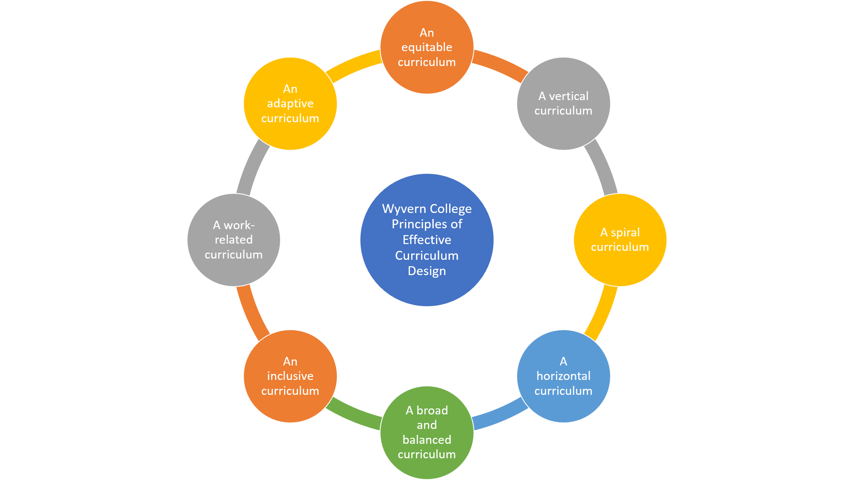

Each course’s curriculum is designed on the basis of eight principles, which can be summarised as:

* **An Equitable Curriculum**- All students access the same curriculum, whichever teacher they have and whatever group they are in.
* **A Vertical Curriculum**- The curriculum is used as a progression model; it unfolds with increasing levels of challenge.
* **A Spiral Curriculum**- The curriculum explicitly identifies for teachers, students and parents the subject’s “Big Ideas” - the essential knowledge, skills and concepts in each unit that need to be retained beyond that unit as they are built upon in later units.
* **A Horizontal Curriculum**- Students’ learning within one subject is linked to their learning in other subjects.
* **A Broad and Balanced Curriculum**- The curriculum balances depth (level of detail given to topics or skills) with curriculum breadth (the range of topics or skills covered).
* **An Inclusive Curriculum**- The curriculum ambition is the same for all students but is made accessible for SEND, low attaining and disadvantaged students.
* **A Work-Related Curriculum**- Within each programme of study there are opportunities for students to learn about work in related industries and sectors of the economy.
* **An Adaptive Curriculum**- Regular planned assessments measure what students have understood from the taught curriculum and there is flexibility to adapt the future curriculum on the basis of this assessment.

See the Appendix for full details of each curriculum design principle.

Our **Principles of Effective Curriculum Design** incorporates the guidance in the **Ofsted 2019 School Inspection Handbook** on the **Quality of Education** judgement, but have additional ambition, including:

* To promote **diversity** through our curriculum content choices
* To incorporate **Cognitive Science research findings** relating to the benefits of retrieval practice, spaced practice and interleaved practice into our curriculum intent and implementation
* The benefits of a three-year KS4 model with a fourth option subject in keeping the curriculum as **broad as possible for as long as possible.**
* **Extra-curricular activities** shared through our curriculum maps to increase the breadth of the curriculum.
* **Super-curriculum activities** shared through our curriculum maps to increase the depth of our curriculum beyond that taught in the classroom.

## Extra-Curricular Activities

Extra-curricular activities are, broadly, any which are complementary to what is taught in lessons: they give students a knowledge and understanding of new things, unrelated to the taught curriculum. Often recreational and experiential, they widen students’ understanding and appreciation of the subject. The department publishes on its curriculum maps the extra-curricular activities available to students. In addition to clubs, competitions, trips and visits, there are suggestions for recreational reading and suggested place of interest to visit with their families.

## Super-Curricular Activities

Super-curricular activities are supplementary to the taught curriculum; they extend students’ understanding of the taught course. They tend to be more academically focused, demanding scholarship. The department publishes on its curriculum maps menus of super-curricular activities connected to each term’s learning. Whereas the extracurricular activities tend to be recreational and experiential, super-curricular activities demand scholarship.

# Personal Development Curriculum

## Core RPS

All Wyvern students follow a Core RPS curriculum through a one timetabled lesson each week across years 7-11. The curriculum meets the **DFE Guidance on PSHE education (Feb 2020)**, including curriculum content on: drug education, financial education, sex and relationship education and the importance of physical activity and diet for a healthy lifestyle. However, the breadth of the Core RPS curriculum exceeds the national guidance, including additional themes such as: world religions, law, the justice system, medical ethics, global equality, the media and mental health. The Core RPS programme supports the college in achieving its third curriculum ambition: [to lead] students to appreciate their place in the modern world, revealing the opportunities it offers them and the responsibilities they owe to it. The appendix provides a unit by unit overview of the Core RPS curriculum.

### STRIVE

Introduced in September 2021 for year 7 and rolling through to year 9, students participate in the STRIVE programme to encourage them to take pride in the activities in which many of them already participate in during their own time and to gain recognition for doing so. The programme, which is delivered during tutor time supports the college in achieving its second curriculum ambition: [to lead] students to personal accomplishment and fulfilment, becoming happy individuals with social maturity and moral purpose. STRIVE develops six key personal attributes in students:

Students learn about each of the six attributes (one per half term) and are supported in enhancing their skills in each by identifying opportunities for them to try new things. Students are awarded bronze, silver and gold badges for successful completion of the programme in years 7, 8 and 9 respectively.

## Assembly and Tutor Time Curriculum

The use of assemblies and tutor time further enable the college to realise curriculum ambitions 2 and 3. Activities are mapped across the vision statement, to provide students with opportunities to think deeply, read widely and discuss openly. Units of work are being formalised for September 2022.

## Careers Curriculum

The careers curriculum is delivered through a range of activities that help to raise aspirations and inspire young people by providing real life contacts with the world of work. It is facilitated through a range of activities including working with employers and further and higher education providers. The Career Development Institute’s (CDI) Career Development Framework state the six career development skills that people need to have positive careers:

* Grow throughout life by learning and reflecting on yourself, your background and your strengths
* Explore the full range of possibilities open to you and learn about recruitment processes and the culture of different workplaces
* Manage your career actively, make the most of opportunities and learn from setbacks
* Create opportunities by being proactive and building positive relationships with others
* Balance your life as a worker and/or entrepreneur with your wellbeing, other interests and your involvements with your family and community
* See the big picture by paying attention to how the economy, politics and society connect with your own life and career

Career development skills are the learning outcomes that career development programmes and interventions should be aiming to bring about. They need to be developed alongside academic skills and knowledge and employability skills.

As part of our planning, evaluation and reflection, Wyvern uses the eight **Gatsby Benchmarks** which are the foundation of our careers strategy, a statutory requirement for secondary schools and colleges. We use the **Compass Careers Benchmark Tool** to evaluate our careers activities. It identifies areas for improvement and is also as the basis for our careers plan for the year.

Wyvern uses a multi-strand approach to delivering careers education through: tutor time activities; planning to share work-related information within the curriculum design of all our subject courses; specific units covering employability skills and careers in Core RPS; and providing students with the opportunity to access impartial, one-to-one careers advice and guidance.

Students take part in a variety of activities e.g. employability interviews, opportunities to meet employers during lesson time, Careers Fair, National Careers Week activities, external visits to workplaces and FE and University workshops. Wyvern students also receive additional support whenever significant study or career choices are being made. The careers curriculum supports the college in achieving its third curriculum ambition: [to lead] students to appreciate their place in the modern world, revealing the opportunities it offers them and the responsibilities they owe to it.

# The ‘Hidden’ Curriculum

In addition to our planned, structured curricula, Wyvern also focusses on the what Matt Bromley (School & College Curriculum Design 1: Intent) defines as the ‘hidden’ curriculum. These are the unplanned, unstructured experiences from which students learn such as from their learning environments, their relationships and interactions with their teachers and peers, from Wyvern’s expectations of their behaviour etc. The hidden curriculum supports the college in achieving its second curriculum ambition: [to lead] students to personal accomplishment and fulfilment, becoming happy individuals with social maturity and moral purpose.