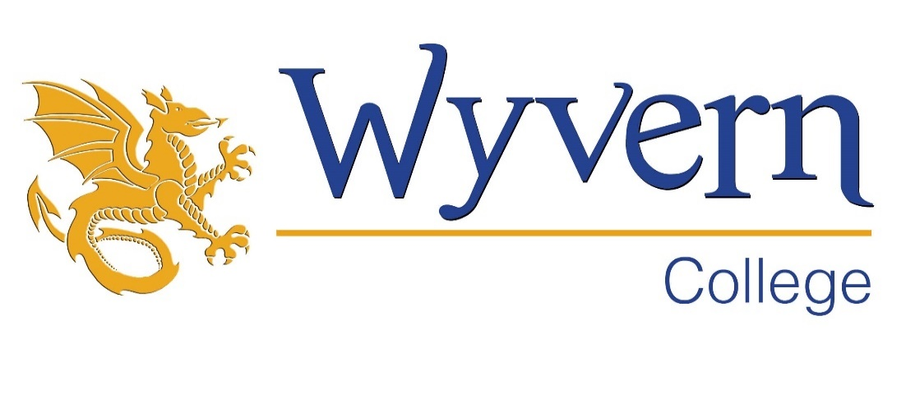

**Teacher of Art**

Salary Scale: MPS/UPS

Required: September 2024 / January 2025

**ADVERT**

We are looking to recruit a teacher to our Art department. This post is a fantastic opportunity to join a creative and passionate team. The Art department secures strong attainment and progress but is equally proud of the positive experience that students have in the classroom. It is committed to continuous improvement and is therefore eager to learn from new teachers who join the department.

The successful candidate will be able to enthuse students with a love of Art. They will be student-centred, passionate, reflective and hard working. They will be collaborative in approach, keen to work with colleagues to share the best practice and resources.

Wyvern College is a popular and happy school, where staff and students feel valued and appreciated. Students are polite, hard-working and well behaved. They are keen to learn and they achieve well above national expectations. Staff morale is high; turnover is low and there is a strong sense of team work and community. Staff are proud of their college and genuinely excited about the next stage of its development. Leaders and Governors are held in high esteem. We have on-site nursery and gym facilities with staff discounts. People rarely leave Wyvern and those who do, often return!

Wyvern is a 11-16 mixed comprehensive school, serving the communities of Fair Oak, Horton Heath, Bishopstoke, Durley and Upham and the surrounding area. Increasingly, families from outside the catchment area are seeking Wyvern places for their children. Consequently, it is oversubscribed.

Application packs available from [www.wyverncollege.org.uk/recruitment](http://www.wyverncollege.org.uk/recruitment)

Please note: CVs will not be accepted as an alternative form of application and will not be placed into shortlisting

**Closing date: Monday 24th June 2024**

**Disclaimer: due to the high volume of applications we receive, we reserve the right to close a vacancy earlier than the advertised date if we receive applications that meet the criteria. Once a vacancy has closed, we are unable to consider further applications, so please submit your application as soon as possible to avoid disappointment.**

Closing date for applications: we will invite candidates in for interview upon receipt of sufficiently strong applications.